Paul-David Ephraim Kinimo

P00189592

Designing and Developing a Website

Assignment title: Vintage Rally

**Task 3 – Test the website and write a test report**

**W3C validation test:**

For this task, we checked our website to make sure it meets the W3C standard. We, found some errors that we corrected. The following images show the fully positive result of the testing:

* Home page

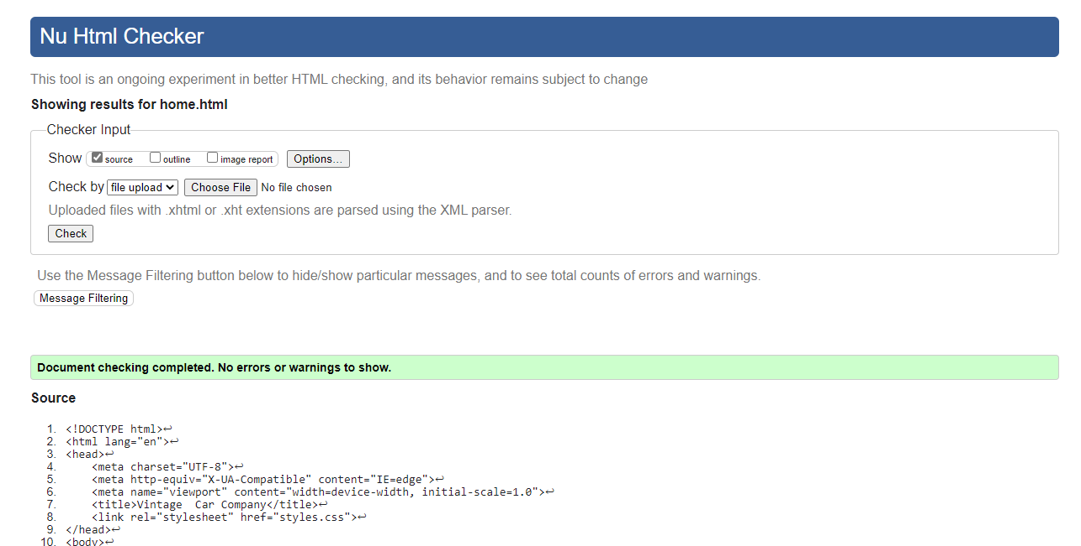

* Contact us page

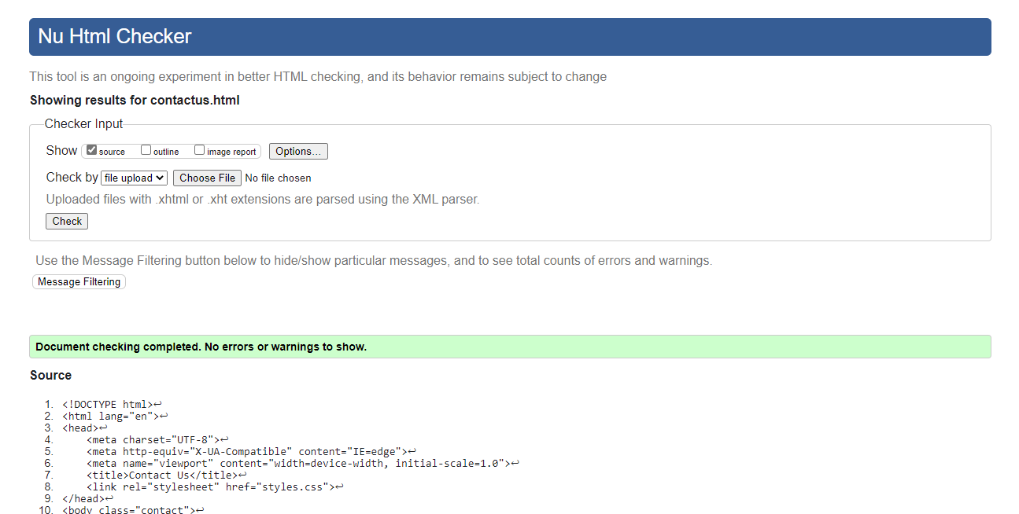

* About us page

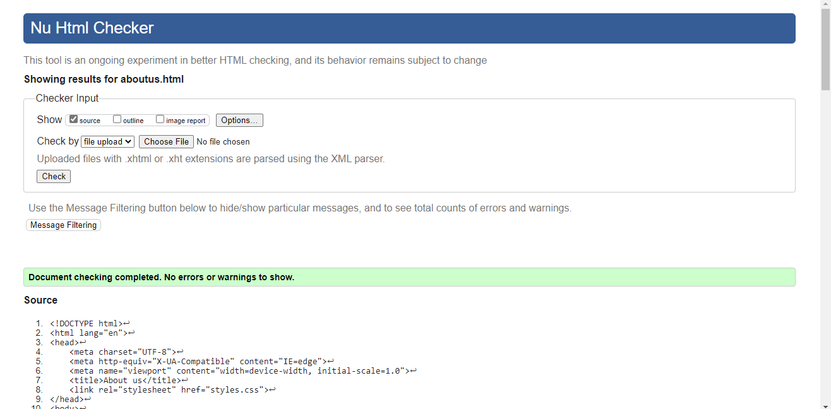

* Q&A page

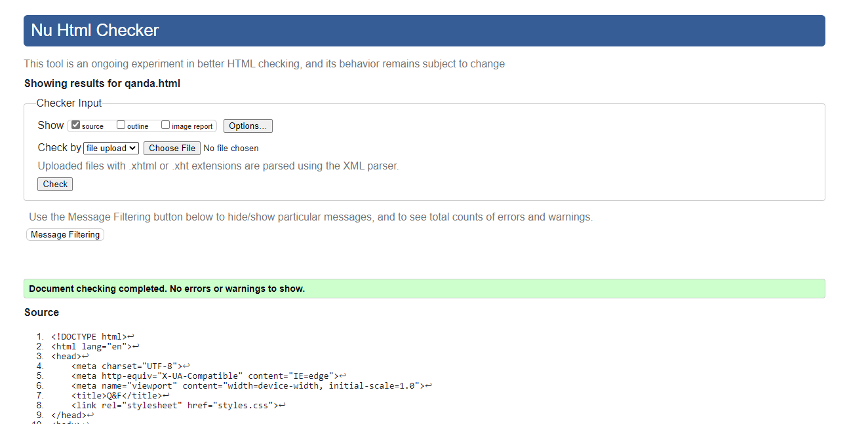

* Register page

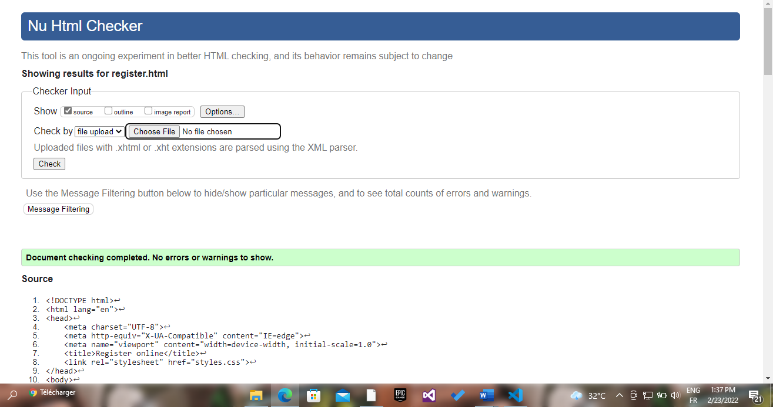

* Our drivers page

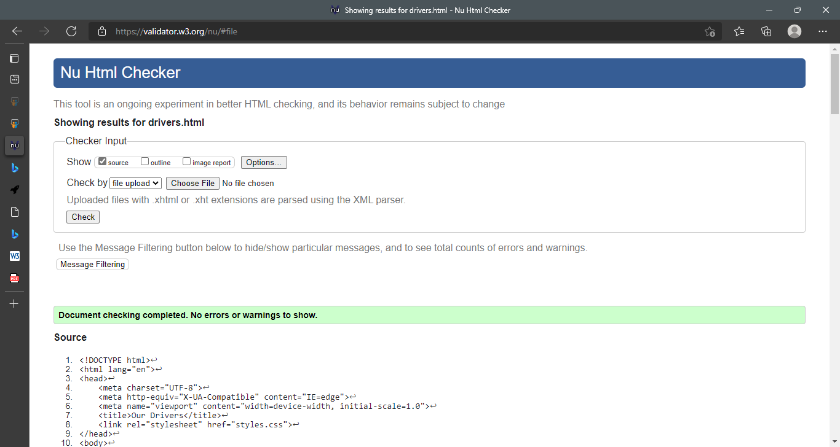

* CSS page – styles.css

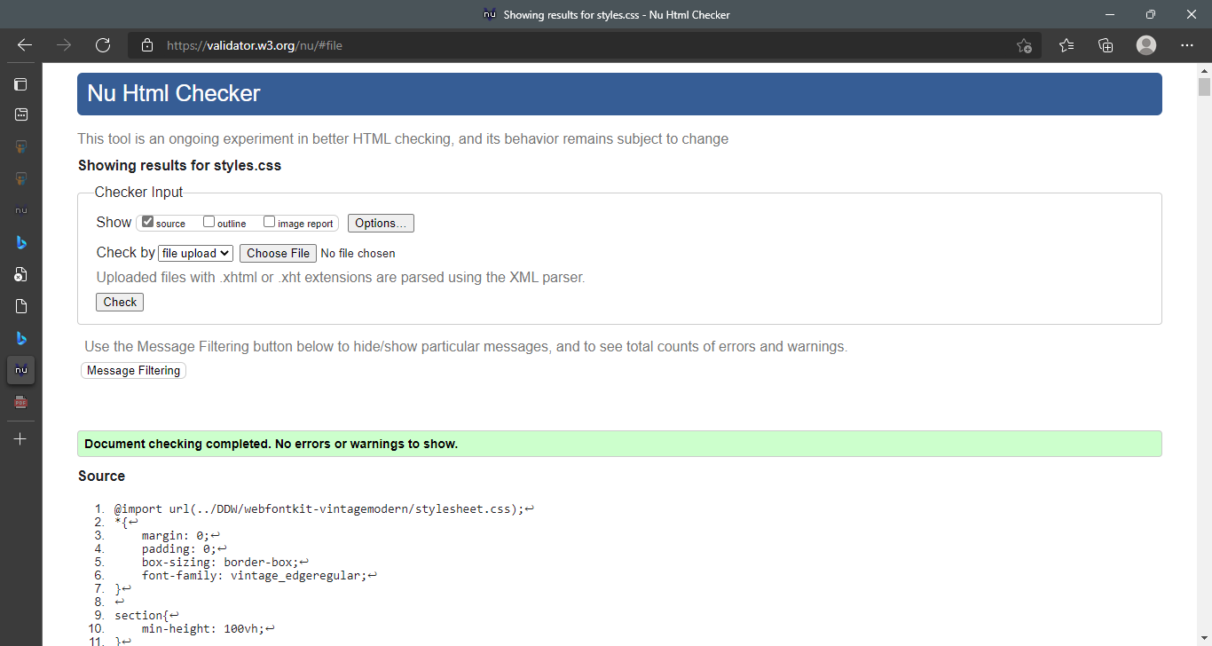

**Accessibility testing:**

The accessibility of a website is important. Disable people should be able to use the website. In order to test the accessibility of the website, we used two screen readers that we found relevant:

* Microsoft edge narrator
* NVDA screen reader: it is a software designed for blind people

The screen reader is perfectly working and reading any selected content and any hovered content.

**Browsers’ comparison:**

The two browsers used for the testing are Google Chrome and Internet Edge.

* Google chrome Edge with 1074 X 768 resolution – Home.html:

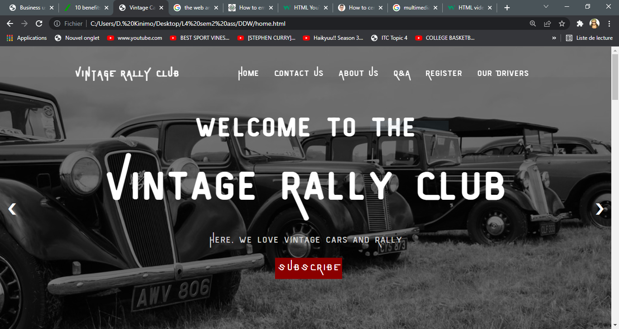

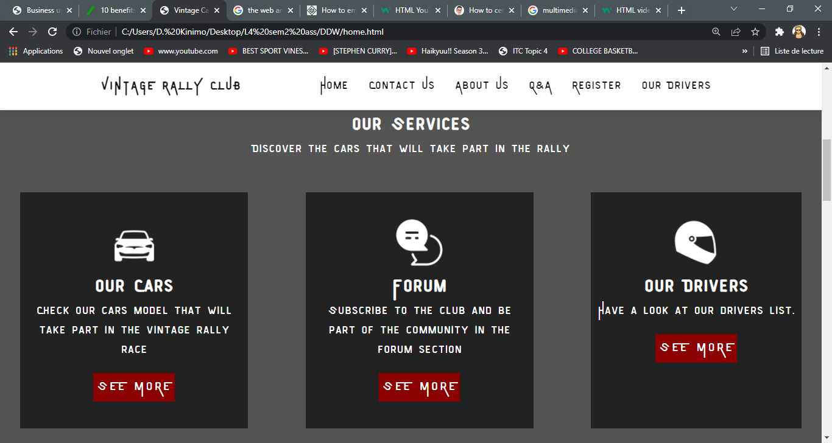

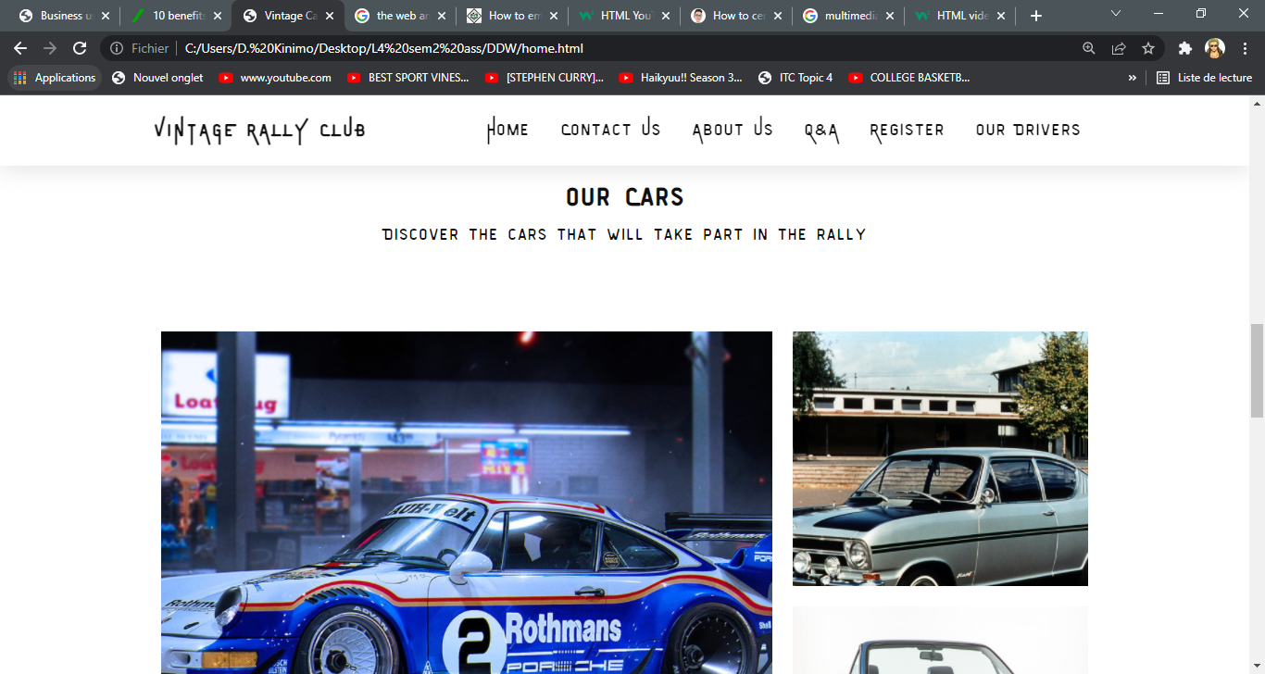

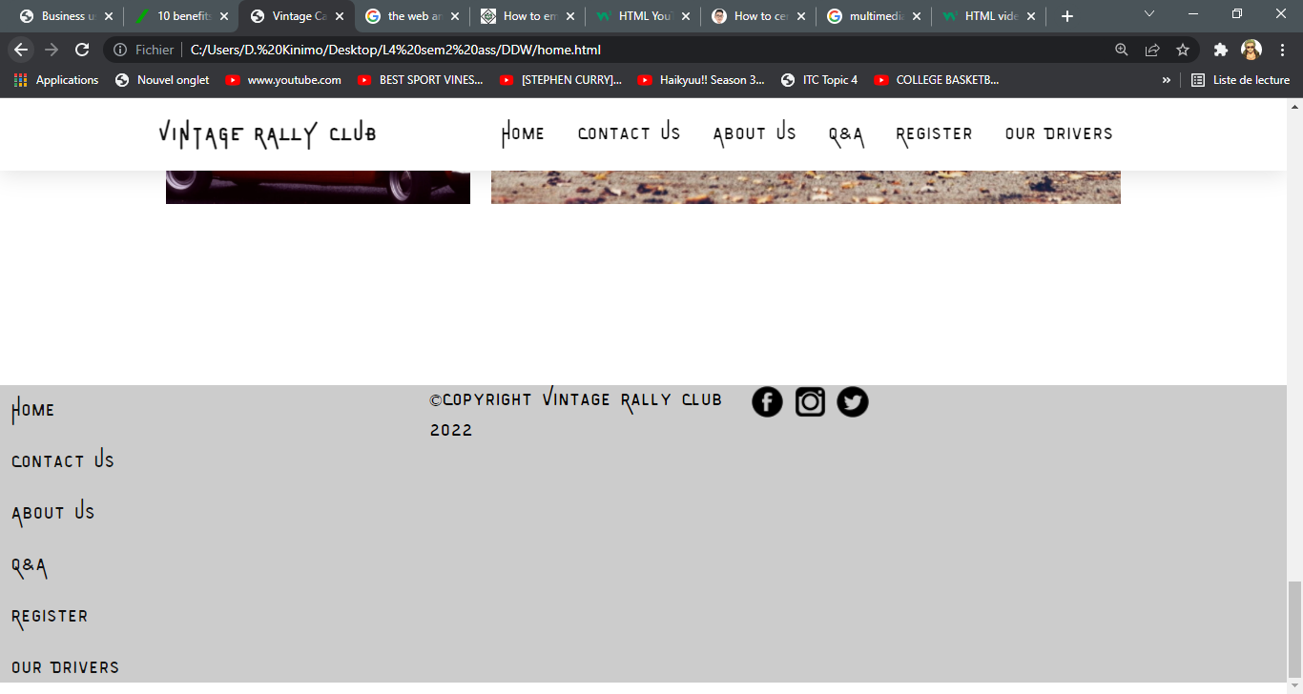

* Internet Edge with 1074 X 768 resolution – Home.html:

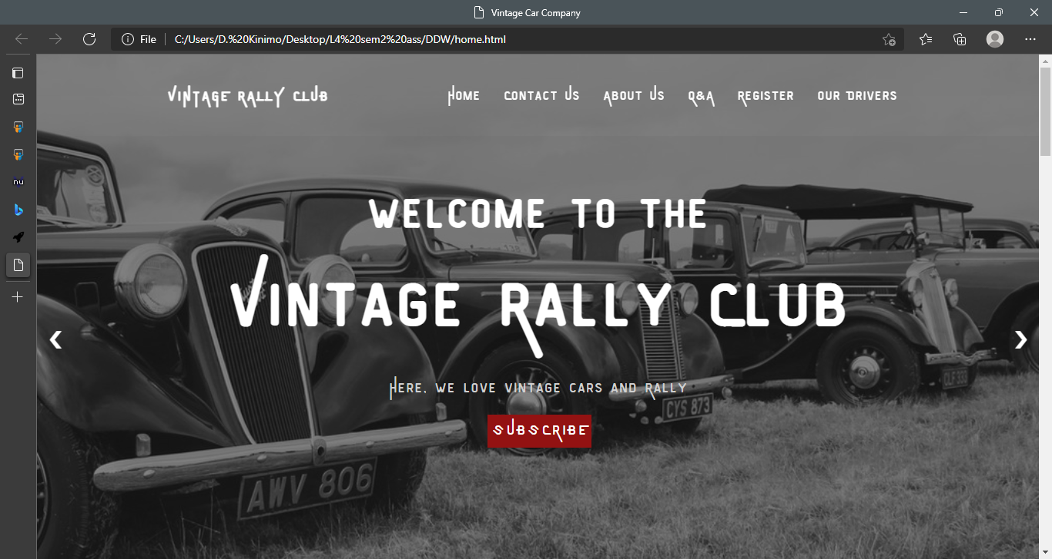

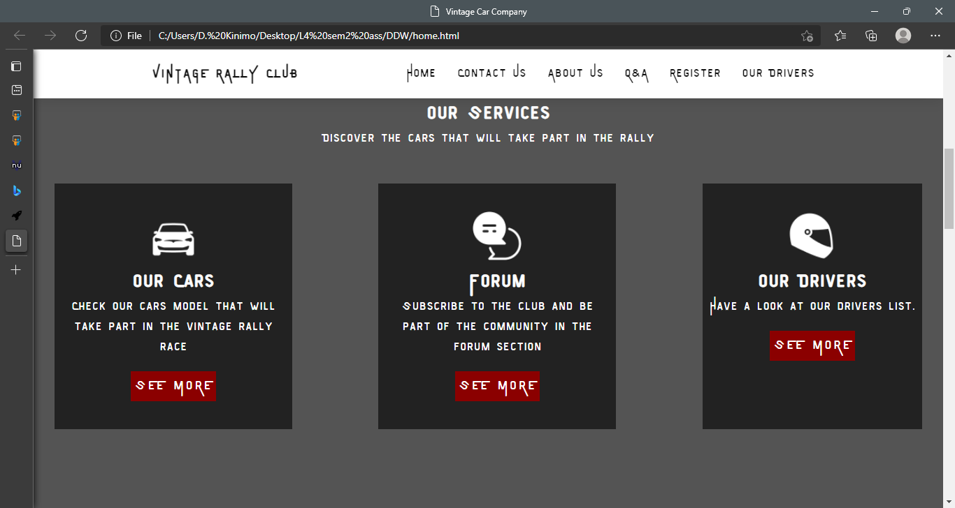

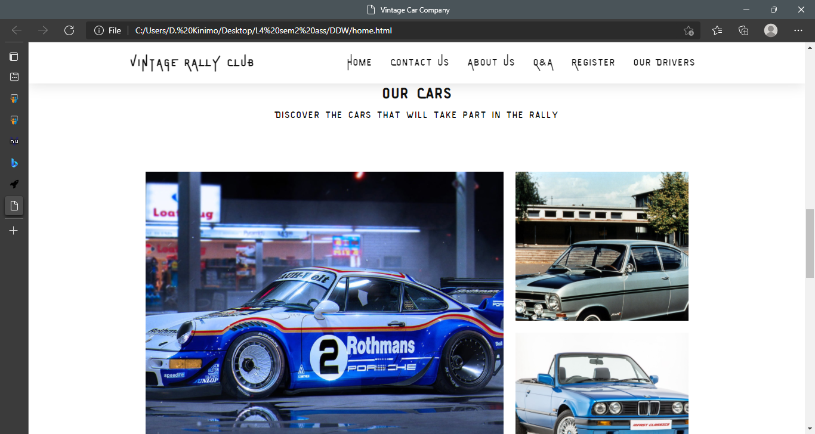

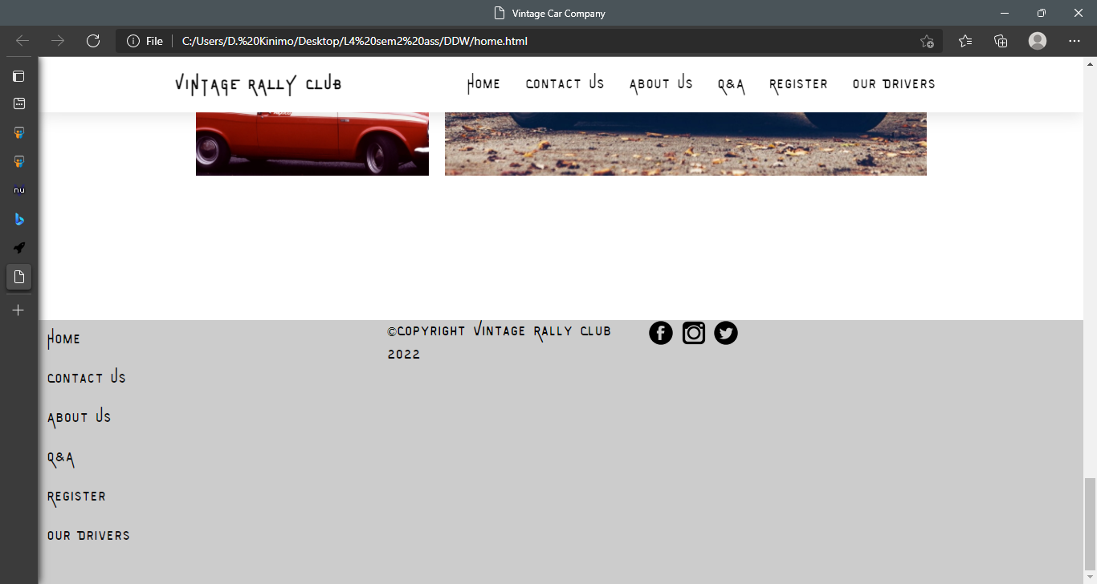

Both of the them seem to work correctly. The main difference spotted is a padding that we notice just under the footer section on the google chrome browser that we don’t see on internet edge.

**Test discrepancies:**

After testing the website, we notice a problem on the register page. On the last section, there is the register form. No problem where spotted unless the we test the responsiveness of the page. The form is not centred in the page which creates additional space on the right side of the page.

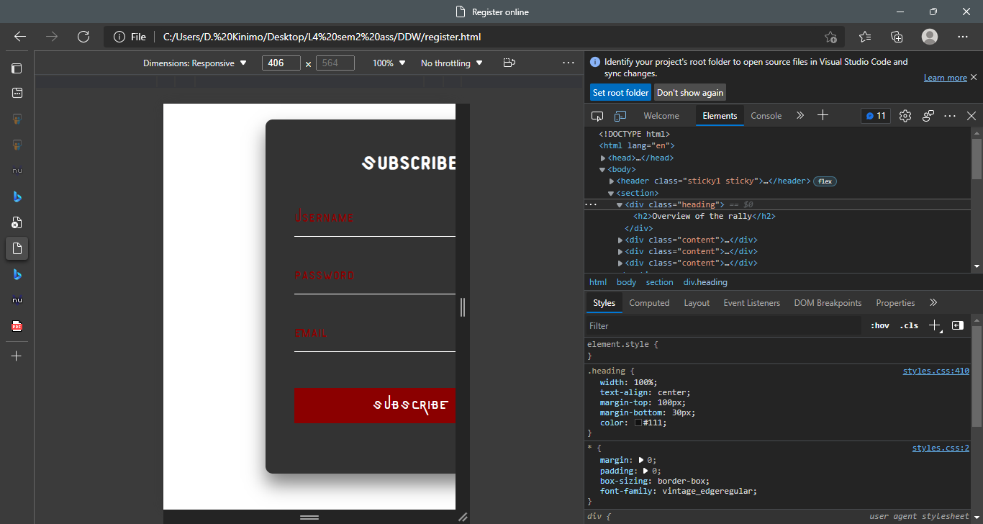

To solve it, I propose to change the padding or the margin of the form in the media selector with the max-width set to 991px.

**Outstanding problems:**

The same problem spotted in the register page still remain because we were not able to rectify it. Even though we used the padding and the margin styles we could not rectify the problem.

**Role of the W3C:**

The World Wide Web Consortium (W3C) is an international organization designed to develop web standards, protocols and guidelines. These are made to lead the web to its full potential and a long-term growth. The role of the W3C is to ensure the development of the web through different aspects:

* The accessibility: the web should be accessible to anyone whoever they are, independently of what they possess as hardware and any disability they may have.
* The compatibility: the web should be present and used on any device from the mobile device to the desktop machine.
* A rich interaction: through the standards of the web structure, the W3C allowed more people to easily use the internet and even be part of its development.
* Trust: nowadays, people meet on the web and share information. The web is a platform of social interaction. That is why, it has to be a safe place where the privacy of everyone is respected.

462 words

**Task 4 – Critical evaluation**

**Accessibility features:**

The accessibility features included in the website are:

* Relevant colours: they allow to make the website user-friendly for people with visibility difficulty or processing information trouble. Relevant colours, are useful to put elements in evidence such as links, buttons and any other element that people need to use on the website.
* Easy navigation: the possibility to navigate through the links without using the mouse is a good feature for people who do not have a mouse to navigate and use the website. The easy navigation also implies the use of relevant links to redirect the audience to pages they are looking for.

**Multimedia component:**

The research for the multimedia component was made on these websites: (<http://search.creativecommons.org/>), (https://www.wallpaperflare.com/)

* In the “about us” page, in the last section we implemented a multimedia component. This component was made with the video tag in HTML and the style in the CSS page. The video element has these attributes:
  + Autoplay: to allow the video to play automatically at the page loading.
  + Muted: to mute the video sound. This attribute was necessary to make the auoplay attribute work.
  + Loop: to loop the video.
* We also used images for the website. We used some as background images for some sections and others as simple image to break up written content.

**Internet and web as business tools:**

The internet refers to a worldwide network of networks and the web can be defined as a worldwide collection of web resources that can be access through the internet. These tools, being accessible and part of people daily lives appear to provide advantages in many sectors. These advantages can also be seen from a business perspective. For the Vintage Rally Club, the use of internet and the web provide first of all communication tools. In fact, through these, the club can communicate with its audience and share the most important news faster. In addition, they allow research and development for the club because they provide access to many resources allowing to enhance the business. Another important point is the use in sales and marketing. The internet provides an online platform for the club that will allow them to advertise their events to a larger targeted group of people and a selling platform in order to sell tickets or any good and services. Through these aspects, the internet and the web would be good tools to enhance the productivity of the club, save time, effort and money.

**Recommendations:**

In order to improve the website, I recommend:

* the implementation of the back-end code to make the website fully functional
* implementation of additional accessibility features such as contrast mode
* if possible, the improvement of technologies uses such as CSS, HTML and JavaScript in order to simplify the code and apply new features to the website.

466 words